Project: TODO Test Plan
Course: CSD380 - DevOps
Description: Module 4 Assignment
Date: 2025/09/04
To complete the test case plan, fill out the information for Project, Course, Description and Date in the header below.

TABLE OF CONTENTS
Access Website Through Standard URL 3
Create a New To-Do Task 4
Delete a To-Do Task 7
Prevent Submitting Empty Task 9
Edit a To-Do Task 11

For each test, the developer should: provide a test description, a test objective, the developer name and date tested. For each step, fill out the actions to be taken and describe the expected results, and indicate yes or no for each step depending upon the result. The peer tester should provide their name, date tested, indicate yes or no for each step depending upon the result, and a screenshot (thumbnail) of the result.

Test 1 | Access Website Through Standard URL
 | Test Objective: Verify that users can access the To-Do application through the provided URL | Developer:  Date tested: 2025/09/04 | Peer tester: Jess Monnier  Date tested: 2025/09/06
Step | Action | Expected results: | Developer pass/fail | Tester pass/fail  + Screenshot
1 | Open a browser and visit https://buwebdev.github.io/todo/ | Website loads without errors | yes | Yes  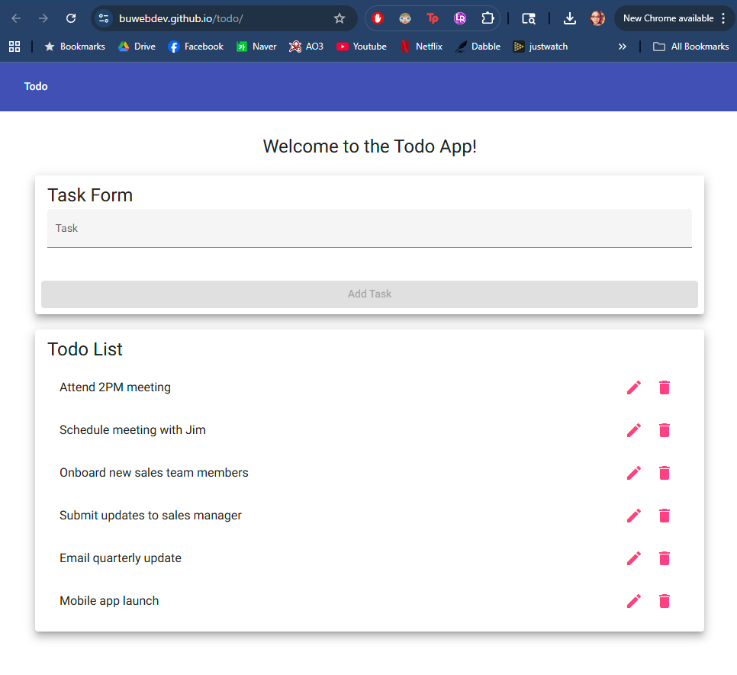
2 | Refresh the browser page | Page reloads successfully without errors | yes | Yes (looks identical to above screenshot)
3 | Click around on the page (e.g., navigation) | All links and app elements respond without breaking | yes | Yes  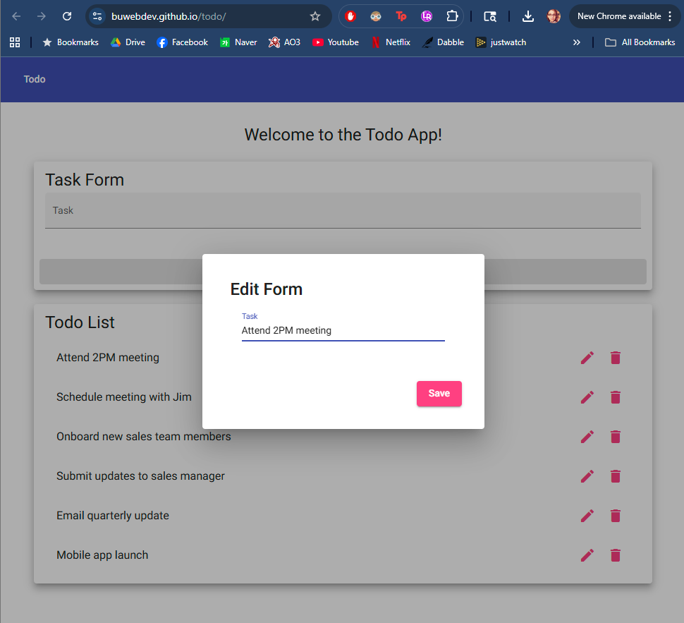
Comments | The site loads quickly and reliably, and the same whether it is manually navigated to or refreshed. There are no real navigational links to speak of, but the edit and trash icons perform as expected and the Task text field is responsive when clicked into.

Test 2 | Create a New To-Do Task
 | Test Objective: Verify that users can add a new task | Developer:  Date tested: 2025/09/04 | Peer tester: Jess Monnier  Date tested: 2025/09/06
Step | Action | Expected results: | Developer pass/fail | Tester pass/fail
1 | Navigate to the To-Do app home page | Page displays task list and input form | yes | Yes  
2 | Enter text into the “new task” field | Text is accepted in the input box | yes | Yes  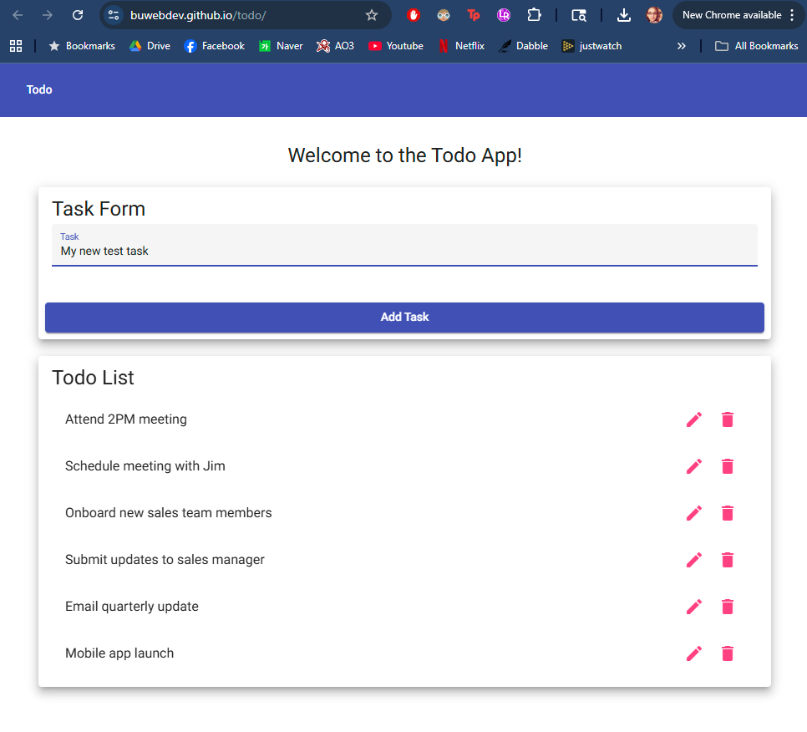
3 | Click the “Add” button | Refresh the browser page | yes | Yes  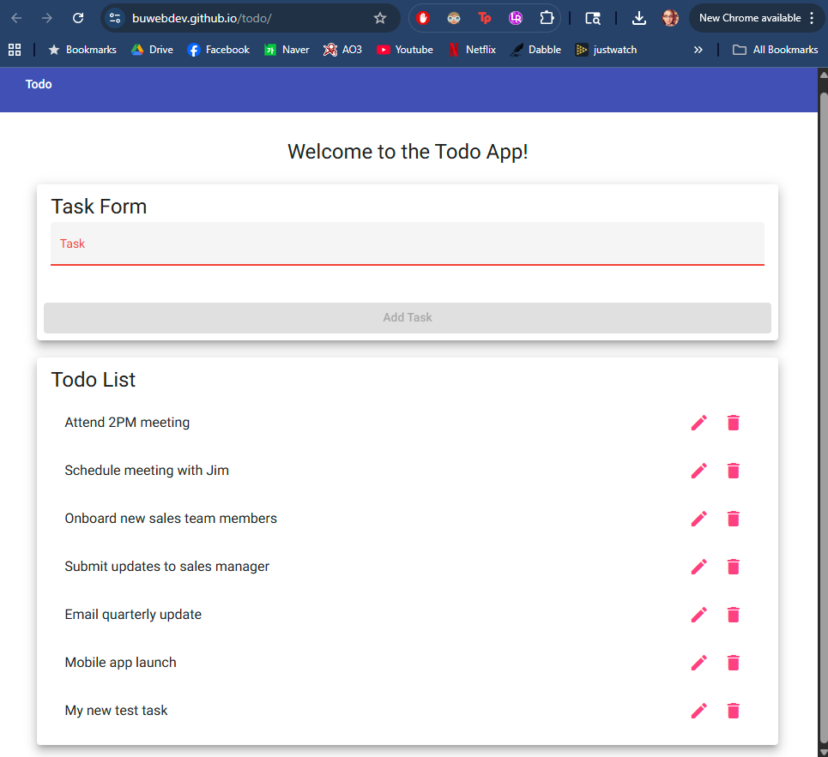
4 | Refresh the browser page | Newly added task still appears in the list (persistent storage check) | no | No  
Comments | The expected result of clicking the add task button is incomplete; it does not only refresh the page but also shows the new task appended at the bottom of the list. The add task functionality is quick and responsive. Refreshing the page reverts all changes, however.

Test 3 | Delete a To-Do Task
 | Test Objective: Verify that users can delete an existing task. | Developer:  Date tested: 2025/09/04 | Peer tester: Jess Monnier  Date tested: 2025/09/06
Step | Action | Expected results: | Developer pass/fail | Tester pass/fail
1 | Navigate to the To-Do app home page with at least one task created | Page displays a task item | yes | Yes  
2 | Click the delete/remove button next to a task | Selected task disappears from the list | yes | Yes  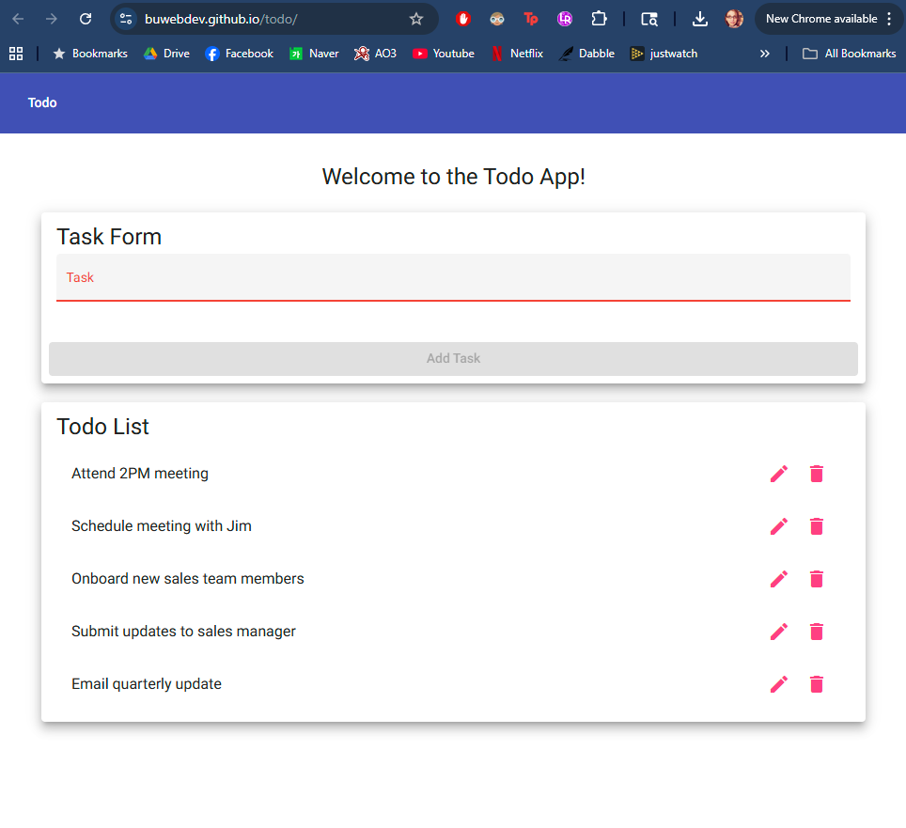
3 | Refresh the page | Deleted task does not reappear | yes | No  
Comments | The delete icons are responsive, quickly reloading the page with that task removed. It might be prudent to add a confirmation dialog in case the icon is clicked accidentally. As with adding a task, refreshing the page reverts all changes.

Test 4 | Prevent Submitting Empty Task
 | Test Objective: Verify that users cannot submit a new task without entering text. | Developer:  Date tested: 2025/09/04 | Peer tester: Jess Monnier  Date tested: 2025/09/06
Step | Action | Expected results: | Developer pass/fail | Tester pass/fail
1 | Navigate to the To-Do app home page | Input field and add button are visible | yes | Yes  
2 | Leave the input field blank | Field remains empty | yes | Yes (same as above)
3 | Click the “Add” button | No new task is created, error message or validation is shown | yes | No (same as above; cannot add because button is disabled)
4 | Add “white space” to the field | Field appears to remains empty | yes | Yes? No? Button enables and cursor is to the right…  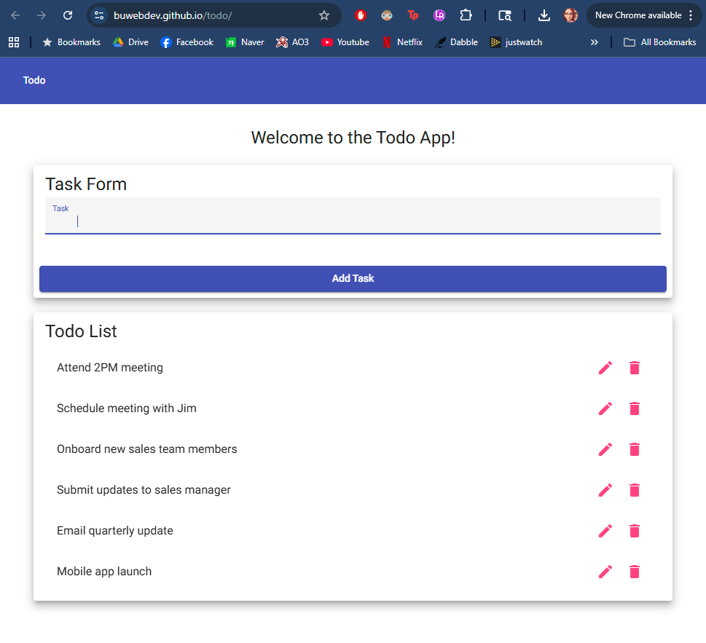
5 | Click the “Add” button | No new task is created, error message or validation is shown | no | No  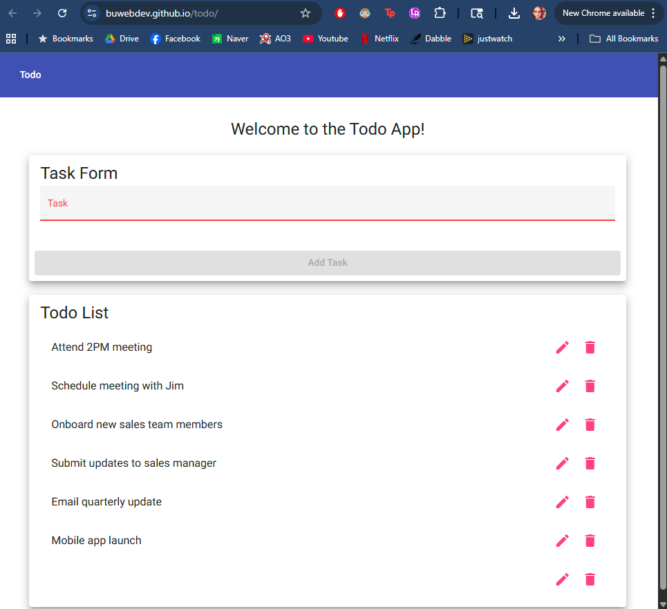
Comments | The Task text field appears to have a minimum character requirement of some kind and the Add Task button is disabled until that minimum requirement is met. However, the requirement can be met by white space, which is not ideal.

Test 5 | Edit a To-Do Task
 | Test Objective: Verify that users can edit an existing task. | Developer:  Date tested: 2025/09/04 | Peer tester: Jess Monnier  Date tested: 2025/09/06
Step | Action | Expected results: | Developer pass/fail | Tester pass/fail
1 | Navigate to the To-Do app home page with at least one task created | Page displays a task item | yes | Yes  
2 | Click the “Edit” option for the task | Task becomes editable (input field appears or text changes to editable mode) | yes | Yes  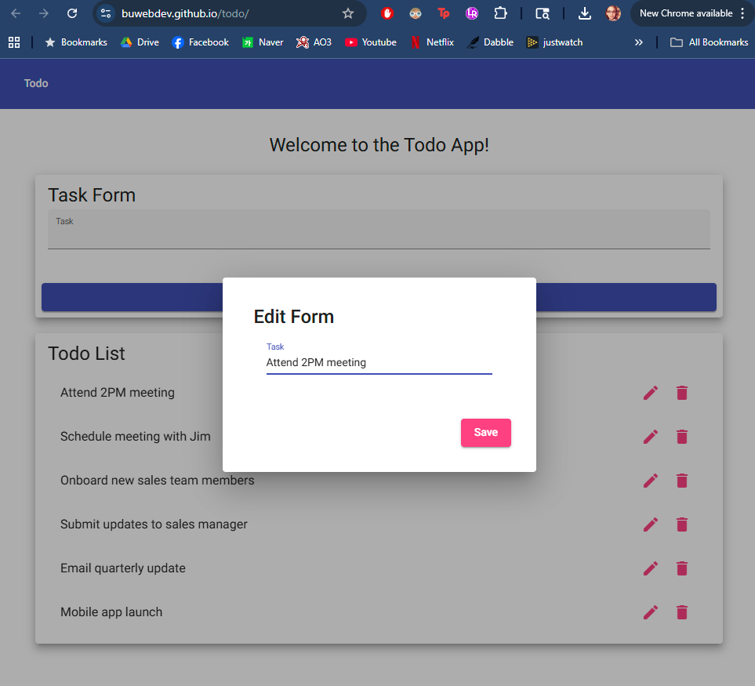
3 | Change the task text and save | Updated task text is displayed in the list | yes | Yes  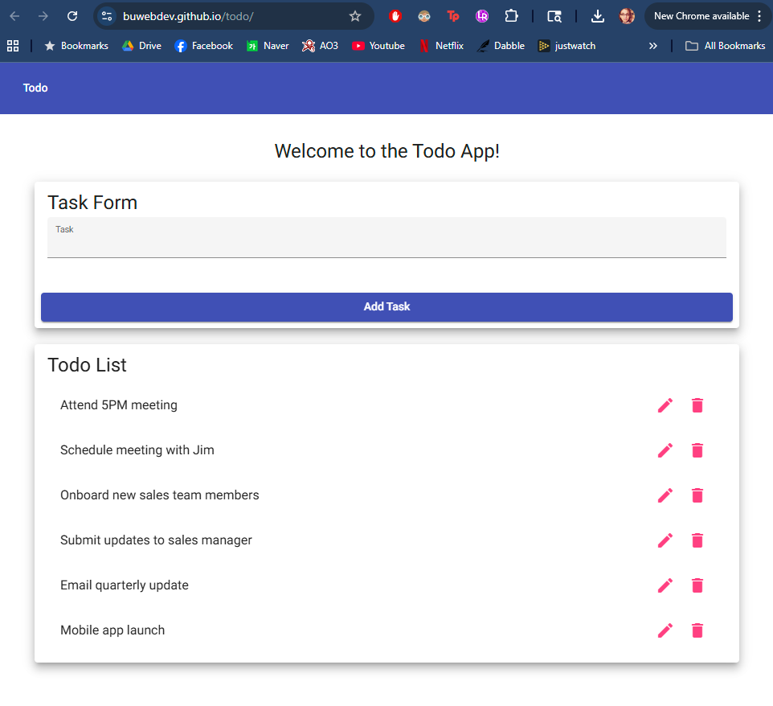
4 | Click the “Edit” option for the task | Task becomes editable (input field appears or text changes to editable mode) | yes | Yes  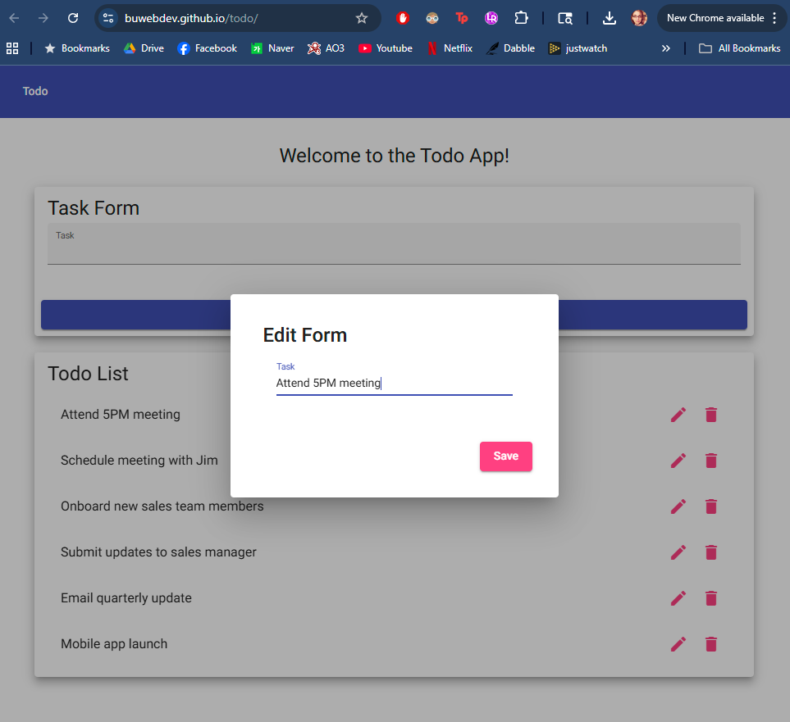
5 | Delete the contents of the task and save it as a blank entry | No new task is created, error message or validation is shown | no | No  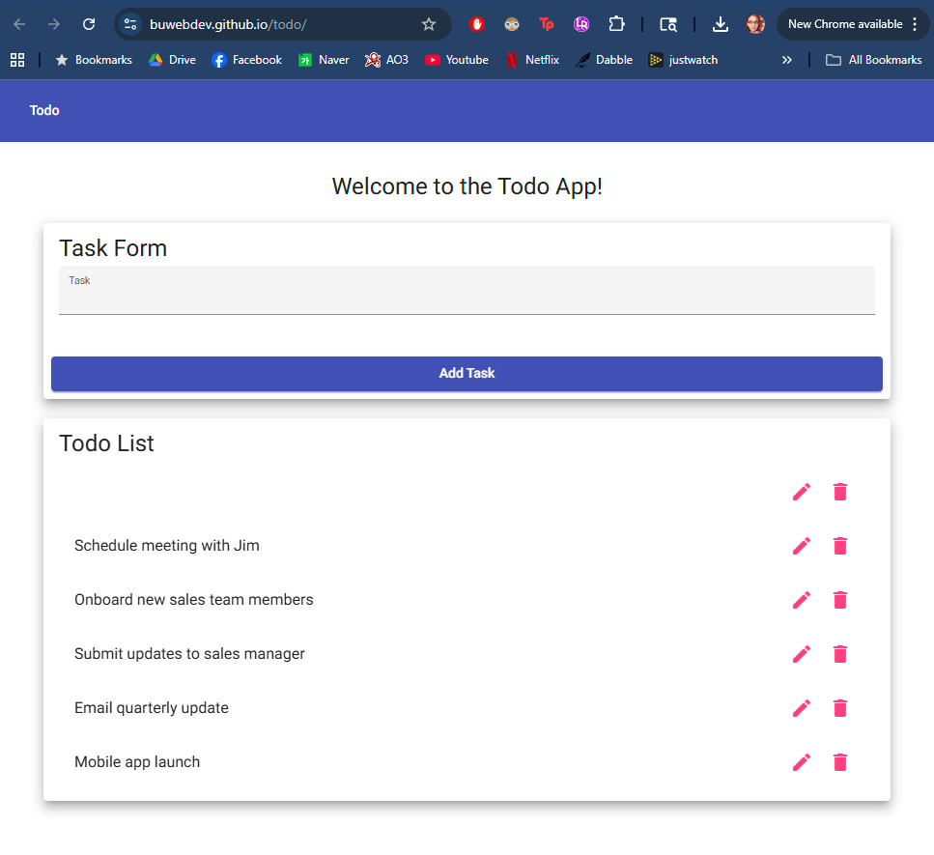
Comments | The edit task icon is responsive, quickly popping up an in-page dialog to edit the task text. Clicking Save refreshes the page with the new task text displayed in place of the old. However, the task text can be deleted, allowing a blank task to be saved. Additionally it might be nice to have a cancel or close button.

